Assignment - 2

UNIX and Shell Programming

TOPIC: FILE SYSTEM COMMANDS

____________________________________________________________________________

1. Create two C files to print “**Hello World!**” in two different ways:
   1. 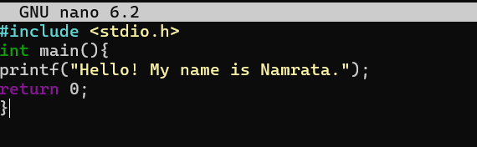Program containing normal statement terminator → HelloWorld1.c.
   2. 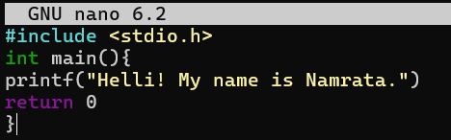Program without any statement terminator → HelloWorld2.c.
2. 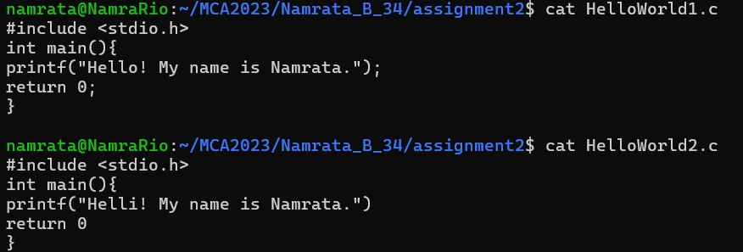Display the contents of the files.
3. 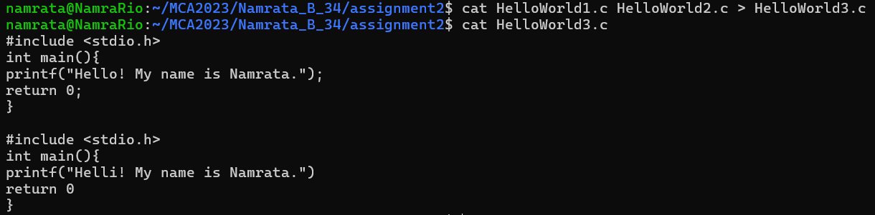Concatenate the two files to a third file.
4. Show the above file types.
5. 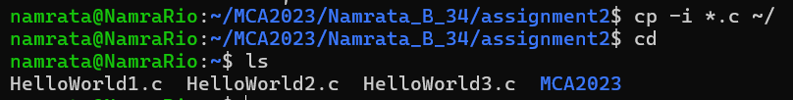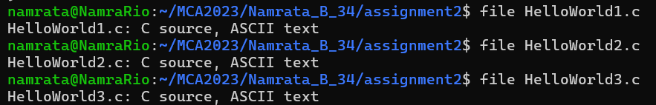Copy all the files to the home directory in an interactive manner.
6. Create a copy of the C file in TestA-1.
7. Copy the file to the home directory in an interactive manner.
8. Remove the directories TestC & TestC-1.
9. Delete the file C file from TestA-1.
10. 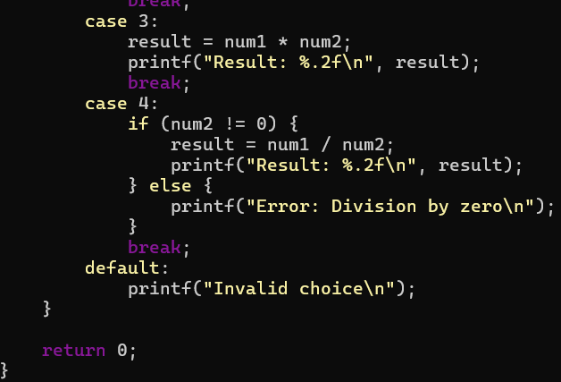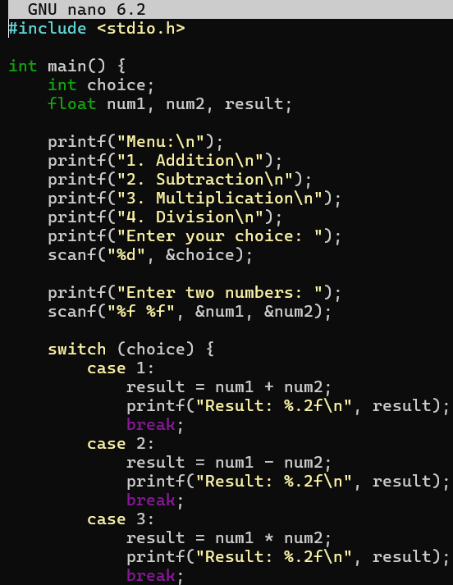Create a C file for a menu driven calculator.
11. 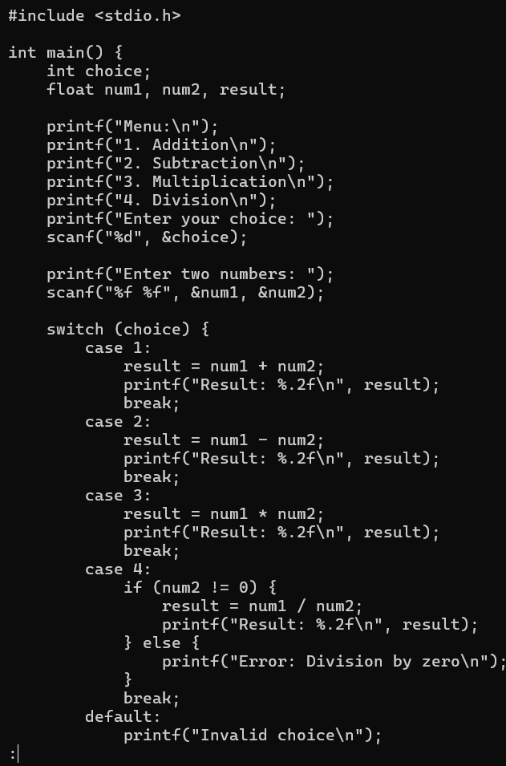Show the C file in the paged manner using **more** and **less** commands.

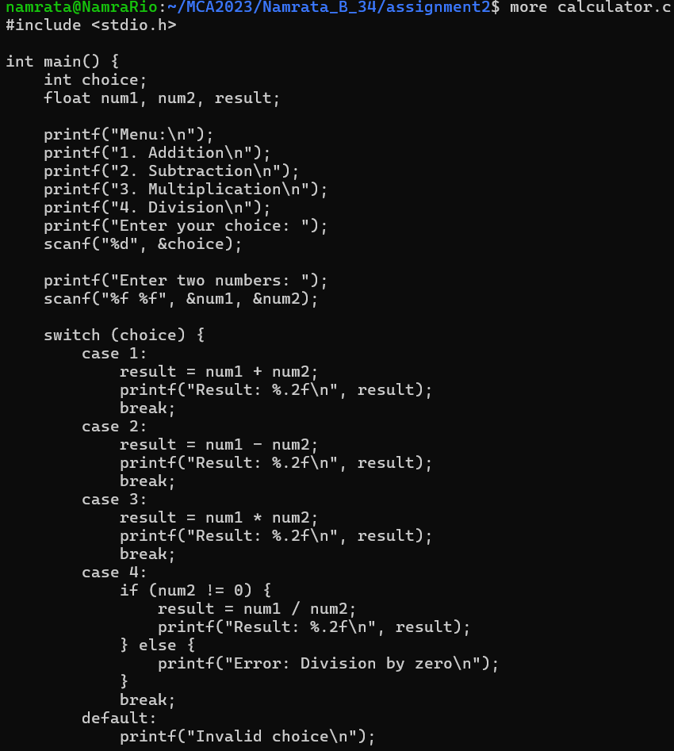

1. Count the number of lines, words and characters separately.
2. 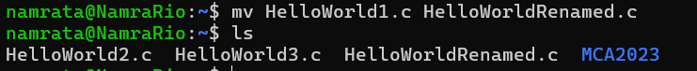Rename the text file in the home directory.
3. Compare the two C files.

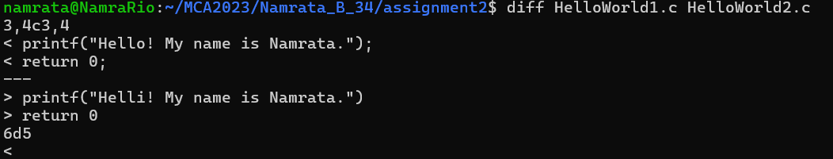

1. 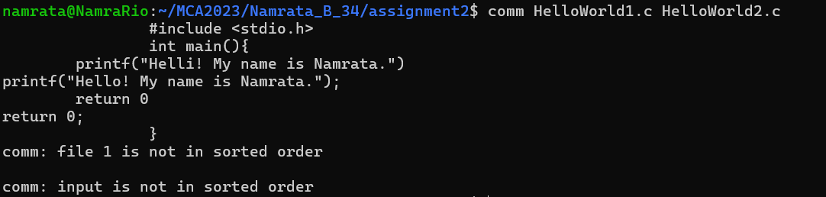Find what is common in two C files.
2. 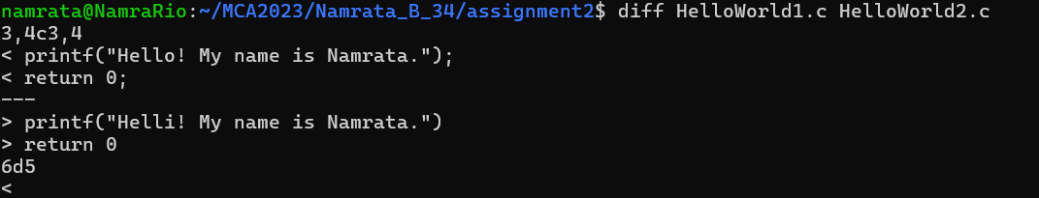Find the difference in two C files.